**Assignment 1**

**Exercise 1**

A survey of grocery stores in the Southeast revealed 40 percent had a pharmacy, 50 percent had a floral shop, and 70 percent had a deli. Suppose 10 percent of the stores have all three departments, 30 percent have both a pharmacy and a deli, 25 percent have both a floral shop and deli, and 20 percent have both a pharmacy and floral shop.

**a.** What is the probability of selecting a store at random and finding it has both a pharmacy and a floral shop?

**b.** What is the probability of selecting a store at random and finding it has both a pharmacy and a deli?

**c.** Are the events “select a store with a deli” and “select a store with a pharmacy” mutually exclusive?

**d.** What is the name given to the event of “selecting a store with a pharmacy, a floral shop, and a deli?”

**e.** What is the probability of selecting a store that does *not* have all three departments?

**Exercise 2**

The screen size for 23 LCD televisions is given below. Make a stem-and-leaf display of this variable.



**Exercise 3**

Brooks Insurance Inc. wishes to offer life insurance to men age 60 via the Internet.

Mortality tables indicate the likelihood of a 60-year-old man surviving another year is .98.

If the policy is offered to five men age 60:

**a.** What is the probability all five men survive the year?

**b.** What is the probability at least one does not survive?

**Exercise 4**

Determine the mean and the standard deviation of the following frequency distribution.

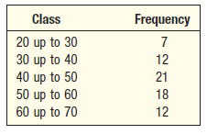

**Exercise 5**

The American Society of PeriAnesthesia Nurses is a national organization serving nurses practicing in ambulatory surgery preanesthesia and postanesthesia care. The organization consists of 40 components, which are listed below.

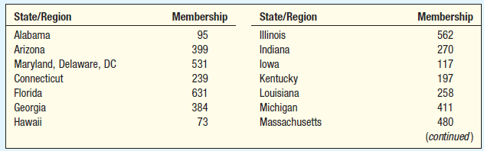

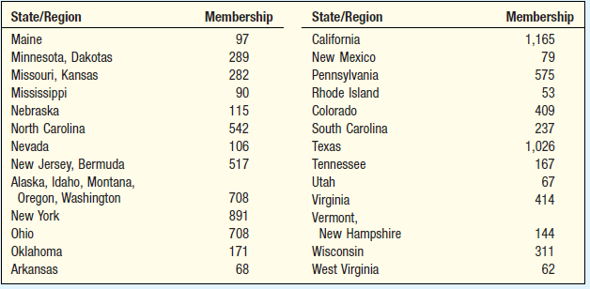

**a.** Find the mean, median, and standard deviation of the number of members per component.

**b.** Find the coefficient of skewness. What do you conclude about the shape of the distribution of component size?

**c.** Determine the first and third quartiles.

**d.** Develop a box plot. Are there any outliers? Which components are outliers? What arethe limits for outliers?